THRYBERGH PARISH COUNCIL
Thrybergh Parish Hall
21 Brecks Lane
Brecks
Rotherham
S65 3JG

Clerk.thryberghpc@gmail.com
01709 545211
07455 897038

Friday 6th June 2025

With reference to the published accounts for Thrybergh Parish Council for financial year 2024/25.

Please note that these accounts are unaudited.

The External Auditor Report and Certificate will be added to these accounts when the audit has taken place later in the year.

Yours Faithfully
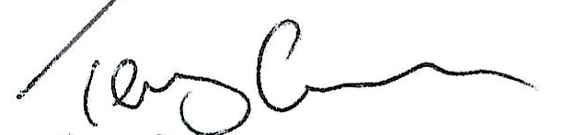
Terry Craven
Clerk & RFO Thrybergh Parish Council

