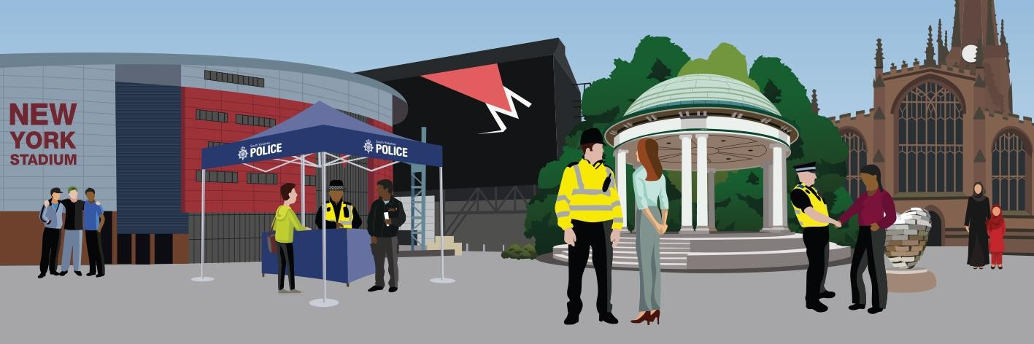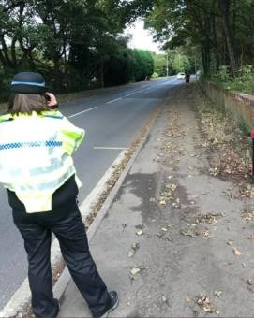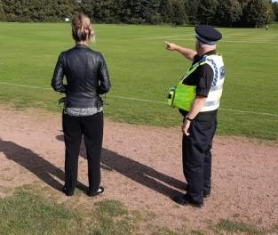

|  |
| --- |
| Rotherham North Neighbourhood Newsletter |
| **November 2020** |
| **You said, we did** |
| In response to the concerns raised from communities over speeding vehicles, the team has completed thirteen speedwatches at the following locations: Wath, Rawmarsh, Harley, Wentworth, Ravenfield, Thrybergh and Swinton.  Over 1,645 vehicles have been checked with 125 vehicles exceeding the speed limit. On a positive note three of these checks (Swinton, Thrybergh and Ravenfield) resulted in no vehicles travelling over the speed limit, which is great for the local community.  The team have been working closely with the Safety Camera Partnership following the results and further action to be taken. |
|  |
| **Crime and antisocial behaviour update** |
| The team continue to target illegal drug use and a number of warrants have been executed in Swinton, Rawmarsh and Parkgate resulting in one man being arrested on suspicion of possession with intent to supply Class B drugs, and hundreds of cannabis plants being seized.  If you are concerned about drugs in your community you can report this to us, or anonomously via Crimestoppers 0800 555111 or online at crimestoppers- uk.org. |
|  |
| **What your neighbourhood team have been doing** |
| Officers from your local team have been out on patrol with the Rotherham outreach youth workers in areas where we would expect young people to gather in Wath, Swinton, Rawmarsh and Woodlaithes.  This multi-agency working aims to engage with young people to give advice about keeping safe and signpost to any appropriate organisations. |

|  |
| --- |
| **Offenders brought to justice** |
| John Marshall, 32, was sentenced in October to eleven years in prison with a further five years on licence.  Marshall pleaded guilty to charges of aggravated burglary, criminal damage and possession of a firearm following an incident at Creighton Avenue, Rawmarsh on 4 February 2020. |
|  |
| **Crime prevention advice** |
| Due to the increase in keyless thefts of motor vehicles, it is advisable to keep your car keys in a metal tin or lined pouch whilst in your house.  This blocks any signal that thieves may try to use from a device to access your keys. |
|  |
| **Keeping in touch** |
| Police Sergeant Craig Cooke, Police Sergeant Ben Szymczyk and Inspector Caroline Bakewell  Telephone- 01709 832 629  Follow us on Twitter @RothNorthNHP and Facebook [Rotherham](https://www.facebook.com/rotherhamsouthNHP/)NorthNHP  Visit SYP’s web site for more info or to report non-emergency crime online: [**www.southyorks.police.uk**](http://www.southyorks.police.uk/)  Call 999 if it is an emergency.  Call 101 for general enquiries or to report a crime in a non-emergency  Call Crime stoppers to give your information anonymously on 0800 555 111  **Sign up for SYP Alerts** to get messages, updates, information about your area – [www.sypalerts.co.uk](http://www.sypalerts.co.uk/) |



